**ECE374 Assignment 1**

01/26/2023

**Group & netid**

*Chen Si chensi3*

*Jie Wang jiew5*

*Shitian Yang sy39*

**Problem 3**

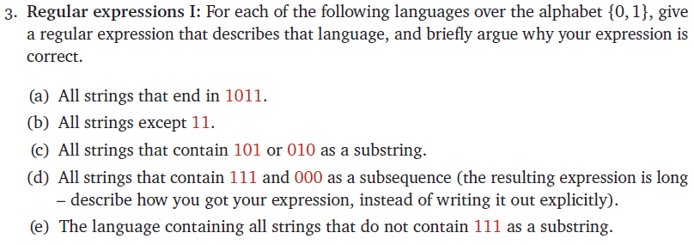

Answer:

(a) Regular Expression:

${\left(0+1\right)}^{*}1011$

Reason:

All strings ending in 1011 must be of the following structure: any-string + ending-string

Therefore, because any string could be represented as ${\left(0+1\right)}^{*}$ and we know the ending string as 1011, we could obtain the regular expression as ${\left(0+1\right)}^{*}1011$.

(b) Regular Expression:

$ϵ+0+1+00+01+10+\left(0+1\right)\left(0+1\right){\left(0+1\right)}^{+}$

Reason:

All strings $w≠11$ satisfy one of following conditions:

(1) $\left|w\right|<2$

(2) $\left|w\right|=2$ and $w≠11$

(3) $\left|w\right|>2$

The first two cases include only a finite number of strings, so we just list them explicitly. The last case includes all strings of length at least 3.

Therefore, we obtain the regular expression as $ϵ+0+1+00+01+10+\left(0+1\right)\left(0+1\right){\left(0+1\right)}^{+}$

(c) Regular Expression:

${\left(0+1\right)}^{*}(101+010){\left(0+1\right)}^{*}$

Reason:

Each string containing 101 or 010 as substring has the following structure: any-string + substring + any-string.

Therefore, because any string could be represented as ${\left(0+1\right)}^{*}$ and we know the substring as either 101 or 010, which could be denoted as $101+010$, we could obtain the regular expression as ${\left(0+1\right)}^{*}(101+010){\left(0+1\right)}^{*}$.

(d)

As the strings in this set has both 111 and 000 as subsequence, there should both be three ones and three zeros in the strings. Therefore, the structure of the strings should be:

any-string + k + any-string + k + any-string + k + any-string + k + any-string + k + any-string + k + any-string

where k should be 0 or 1.

As we know that any-string could be represented as ${\left(0+1\right)}^{*}$, we have to fill in the six k spaces with 3 zeros and 3 ones to form a part of the regular expression.

Thus, we could find the following 20 combinations of 3 ones and 3 zeros.

0 0 0 1 1 1

0 0 1 0 1 1

0 0 1 1 0 1

0 0 1 1 1 0

0 1 0 0 1 1

0 1 0 1 0 1

0 1 0 1 1 0

0 1 1 0 0 1

0 1 1 0 1 0

0 1 1 1 0 0

1 0 0 0 1 1

1 0 0 1 0 1

1 0 0 1 1 0

1 0 1 0 0 1

1 0 1 0 1 0

1 0 1 1 0 0

1 1 0 0 0 1

1 1 0 0 1 0

1 1 0 1 0 0

1 1 1 0 0 0

Therefore, the regular expression that we wanted in this question should be the union of the single regular expressions formed by inserting these combinations of 0s and 1s in the k places in:

${\left(0+1\right)}^{*}k{\left(0+1\right)}^{*}k{\left(0+1\right)}^{*}k{\left(0+1\right)}^{*}k{\left(0+1\right)}^{*}k{\left(0+1\right)}^{*}k{\left(0+1\right)}^{*}$

The full regular expression printed by python is:

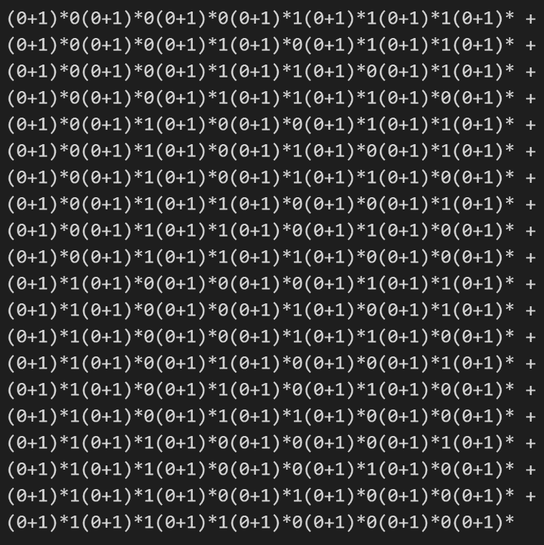

(e) Regular Expression:

${\left(0+10+110\right)}^{*}\left(ϵ+1+11\right)$

Reason:

As strings in this set doesn’t have three consecutive 1s, all consecutive “blocks” of 1s must be of length 0, 1, or 2.

Each string in this set only contains building blocks of 0, 1, or 2 consecutive ones, separating with 0. Therefore, the main part of the strings are composed of ${\left(0+10+110\right)}^{*}$, which shows that these main parts are made of several concatenated 0, 1, or 2 consecutive ones plus 1 separating 0.

Considering that it’s possible for the strings to end in 0, 1 or 11, we add $\left(ϵ+1+11\right)$ to show this end.